UNIT TESTING FRAMEWORK FOR TEST DRIVEN DEVELOPMENT
(MOCKITO JUNIT)

- Test-driven development:
Test-driven development (TDD) is a software development process that relies on the repetition of a very short development cycle:
- First the developer writes an (initially failing) automated test case that defines a desired improvement or new function
- Develops the minimum amount of code to pass that test cases
- Finally refractors the developed code to defined coding standards.

- Test Driven Development Cycle
  - Add a Test
  - Run all tests and see if the new one fails
  - Write some code
  - Run tests and Refractor code
  - Repeat

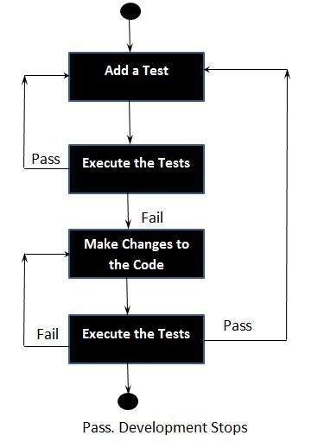

Context of Testing:
- Valid inputs
- Invalid inputs
- Errors, exceptions, and events
- Boundary conditions
- Everything that might break

Benefits of Test Driven Development (TDD) :
- Much less debug time
- Code proven to meet requirements
- Tests become Safety Net
- Near zero defects
- Shorter development cycles

- Junit And Mockito Framework:
Junit is a simple unit testing framework for the Java programming language. Junit is simple yet elegant way to achieve Test-driven Development for a particular project.

Mockito is a popular mock framework which can be used in conjunction with JUnit. Mockito framework allows the creation of test double objects (mock objects) in automated unit tests for the purpose of Test-driven Development (TDD). Using Mockito simplifies the development of tests for classes with external dependencies significantly.

There are different API's in Junit and Mockito which allows developer to mock, stub, assert, verify the code flow and output. You can find the Required documentation about Mokito and Junit from below links.
Junit: http://junit.org/junit4/
Mokito : http://mockito.org/

NOTE: Basic examples of the Junit API'S are explained in the further sections of the document. Please click here for Traversing to the Examples.

- Junit and Mockito Unit Testing Framework setup for a Demo Project in Eclipse:
- Create New ATG project in eclipse or copy the attached folder ProductImport and paste it in C:\ATG\ATG11.0 path. Import this ATG Project into your eclipse workspace.

- Once we have imported the ATG ProductImport project, We could see the below java files (highlighted in Red) and JUnit files (highlighted in Green)

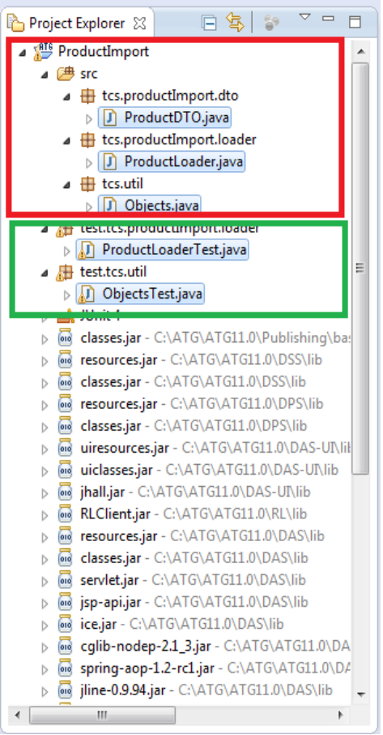

- Add the below jar's in the Project Java Build Path.
junit-4.3.1.jar
mockito-all-1.9.0.jar
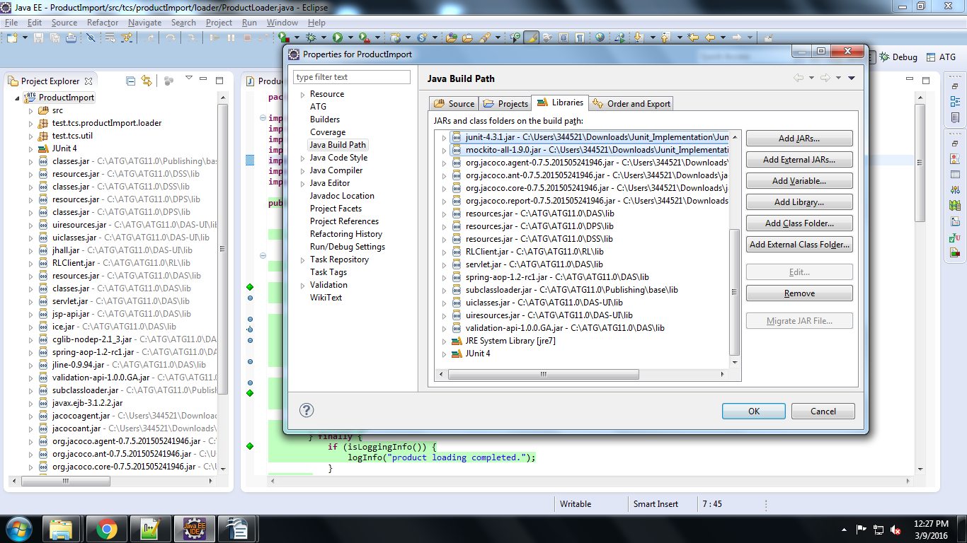
Note: If any other jar's missing in the Java Build path add the ATG missing jar's (DAS (C:\ATG\ATG11.0\DAS\lib) and Publishing(C:\ATG\ATG11.0\Publishing \base\lib) )

- Include Coverage plugin in eclipse.
Eclipse ---> Help ---> Eclipse MarketPlace. In Find type 'coverage' and proceed to search.
Select 'EclEmma Java Code Coverage' from the below search result and click install.

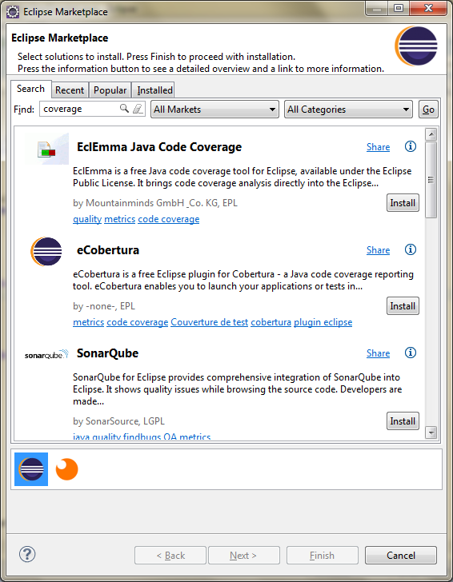
- Select EclEmma Java Code Coverage and click 'Next'
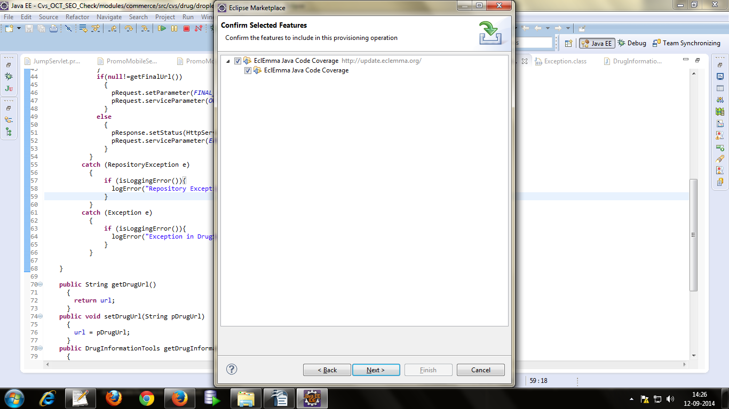
- Restart the Eclipse for the configuration Changes to reflect.

- If not having access to install Coverage plugin in eclipse, Copy the attached folder eclemma-2.3.2 and paste it in any path. Go to eclipse Help → Install new soft ware
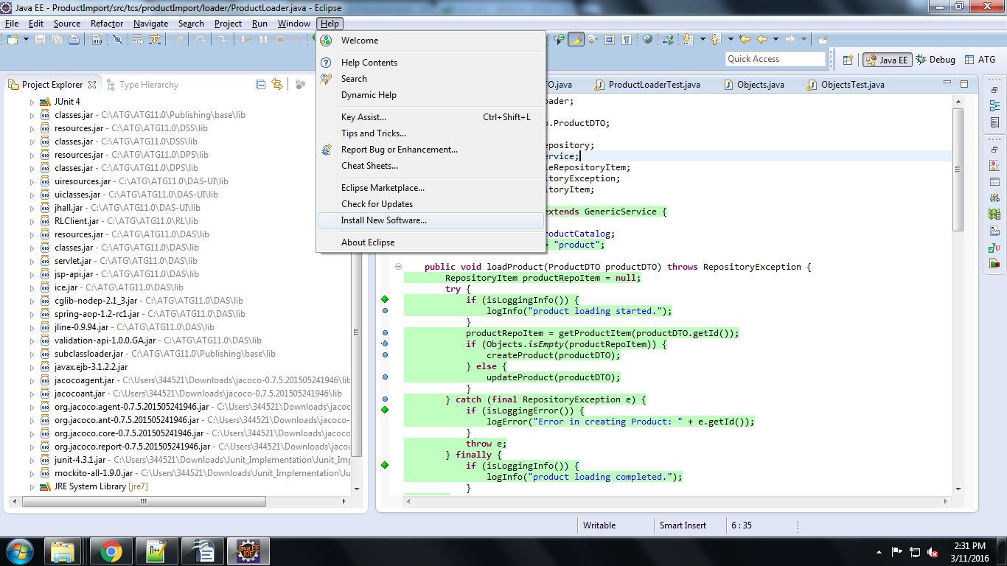
- Type below details and click on the eclemma plugin
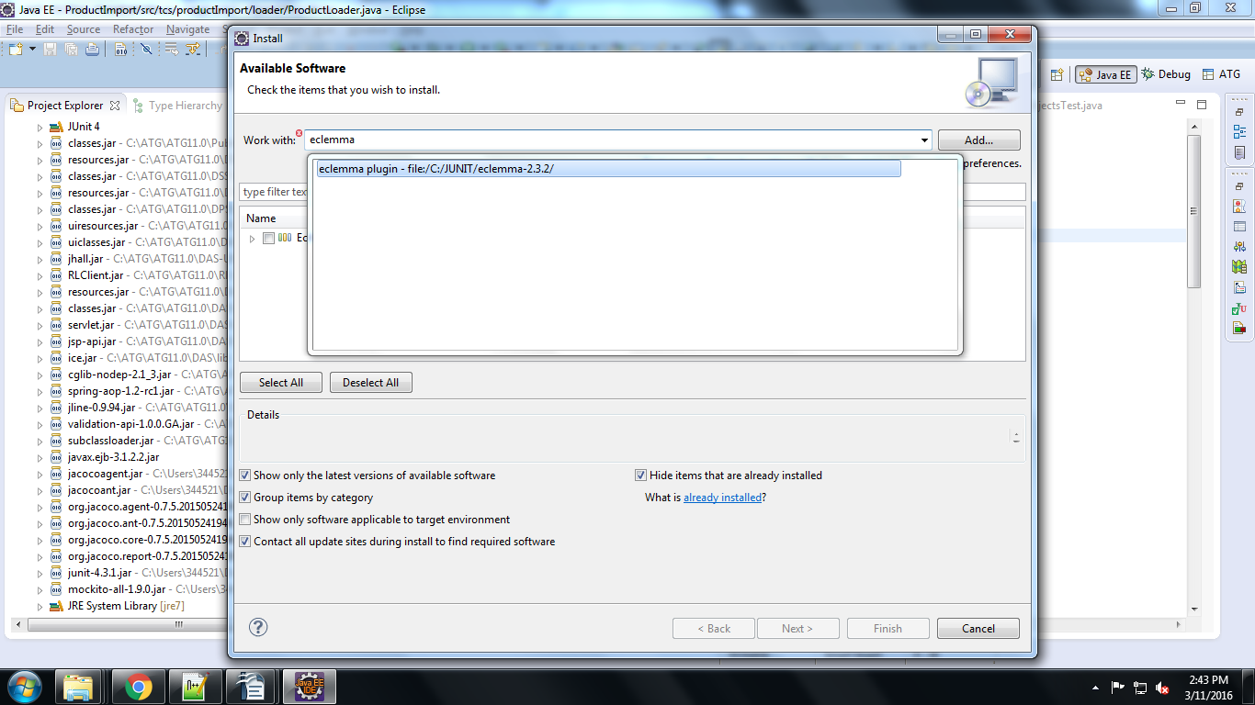
- Select eclemma and click next and accept the terms of the license agreement and click Finish button.
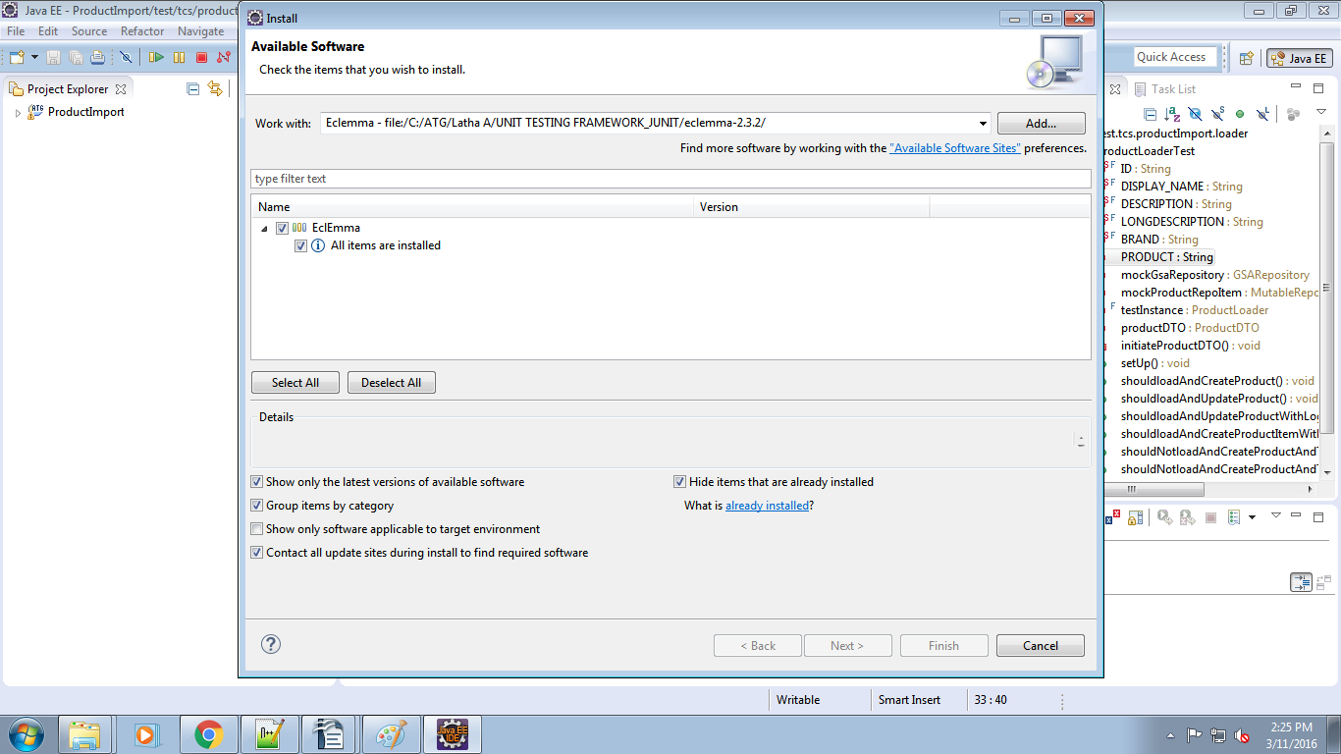
- Restart the Eclipse for the configuration Changes to reflect.
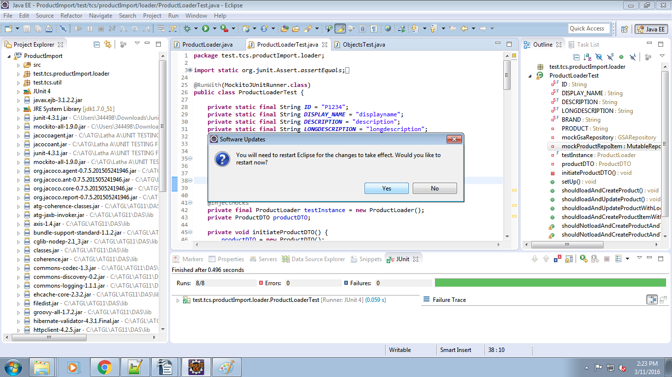
- Also add the below jar's in the Project Java Build Path. (PFA jars)
Jacocoagent.jar
jacocoant.jar
org.jacoco.agent-0.7.5.201505241946.jar
org.jacoco.ant-0.7.5.201505241946.jar
org.jacoco.core-0.7.5.201505241946.jar
org.jacoco.report-0.7.5.201505241946.jar
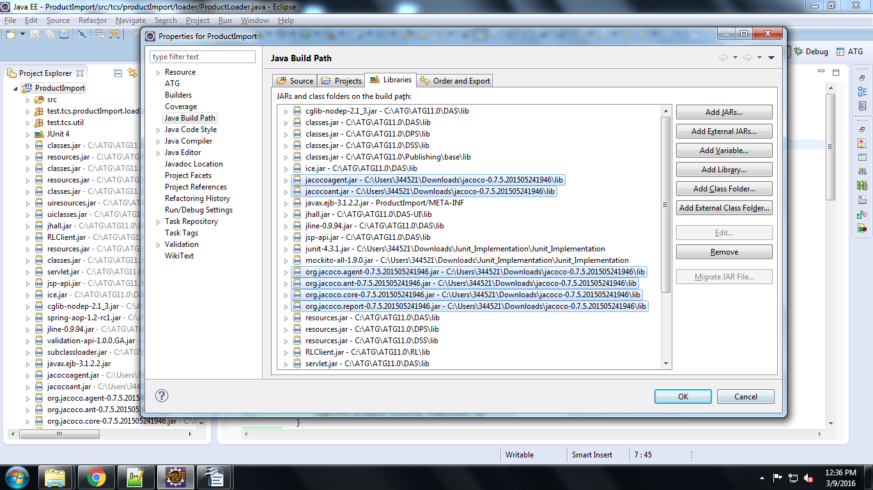
- Demo Java and JUnit logic implementation for a Sample Codebase:
Business Requirement:
Create/Update a Product Item and Store it to Product Catalog Repository.
Technical Analysis:
According to the business Requirement, they require a code which will allow the application to create, update and retrieve product Item from the Product Catalog Repository.
Implementation Steps:
- Create JUnit test class in eclipse:
Go to File → New → Other → JUnit Test Case
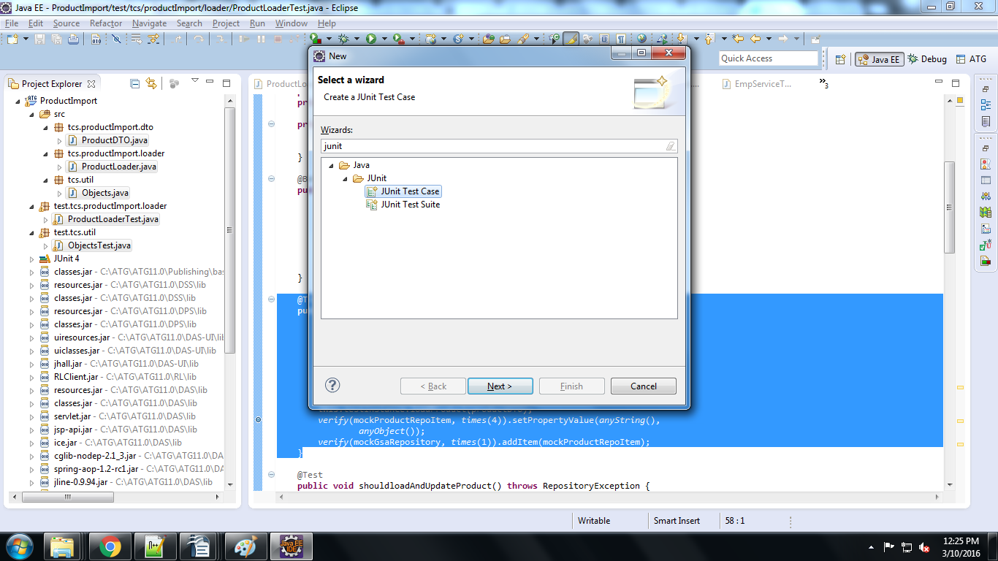
Click on next and enter the JUnit file name then click on finish. Then the JUnit test class will be created.
- Write Methods to test the functionality of Create, update and Retrieve Methods.
There will be separate Test methods for Each flow , Success and error scenario available for this particular feature implementation.

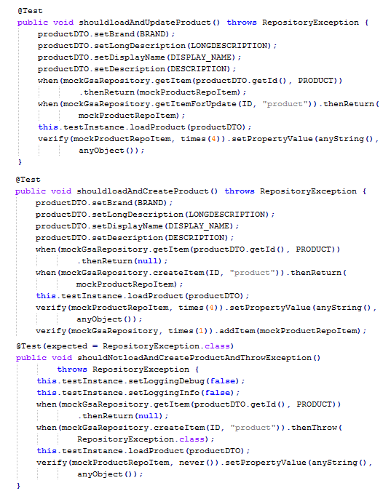
- Create Actual Java Class inline with the Test class developed in the above step.
In this class, we need to create the actual Java file with actual business logic in accordance to the Junit class developed by above step. The aim of the step is to get the Junit test class to pass . There is no need to worry about implementing the defined coding practices and performance oriented development.
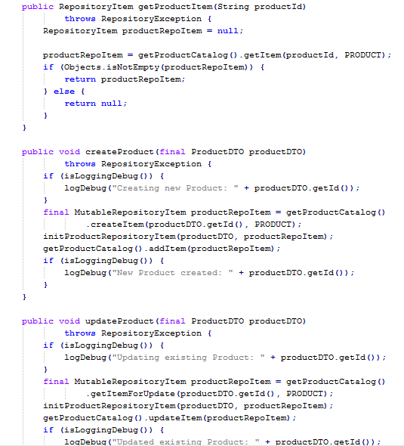

How Test class methods relates to java class methods:

- Refactor the code to implement the defined Standard Coding Practices
In this Step we need to refactor the Java class according to the defined Coding practices to get the final version of the code.

- Execute the final Test case to review the code coverage.
In this Step, we execute the test class and verify the coverage. Once the Code coverage is satisfactory then the development is complete.

- How the test cases relates to java Test methods:
In our Demo example, the ProductLoader is our java class and the ProductLoaderTest is our Junit Test class. Below shows the step by step process of creating a Test class for the required functionality.
- Create variables required as inputs to the methods being tested.
private static final String ID = "P1234";
private static final String DISPLAY_NAME = "displayname";
private static final String DESCRIPTION = "description";
private static final String LONGDESCRIPTION = "longdescription";
private static final String BRAND = "Nike";
- Create mock objects(Dummy Java object) for all the different java classes referenced in the current class.

@Mock
private GSARepository mockGsaRepository;

@Mock
private MutableRepositoryItem mockProductRepoItem;

- Create a Initialization methods and Setup methods where all the required data and Stubbing is done.

@before Annotation makes sure that this method gets executed before a test case is executed.
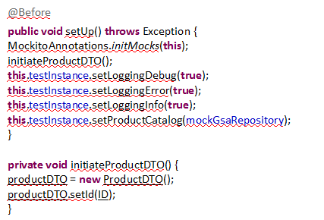

- Create Test Methods which will test all the flows that are available for developing a particular functionality.

NOTE:Different Methods should be written for all the different flows, branches(Conditional statements), Scenarios etc.. Each test case should test only one particular flow and should have either an assert or verify statement to validate the output.

In our demo application we have different functionality like update Product, Create product, get Product. We will be discussing about one particular functionality in detail below.
- updateProduct():
The basic business functionality of Update product is to update the already existing product from the database.
The possible test cases for this particular feature would be
- Update product with all its properties
- Update Product without its properties
- Update Product and check if the logging is working.
- Update product process failure
- Update Product Process failure and Logging check
Once we determine the possible test cases, we should carry on with creating test methods for each of this scenarios. All the methods should be annotated with @Test, this enables Junit to recognize between private methods and test methods.

- Update product with all its properties: In this method as you see all the required properties are set to the product. Along with mock objects are stubbed using when then API to emulate a particular class functionality. Since the return type is null, instead of assert we use to verify if its calling the correct methods.
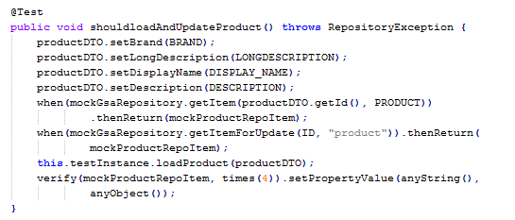
- Update Product without its properties: In this Test method as well, we see that the product is updated, but the product variables are not set, thus emulating our required test case.
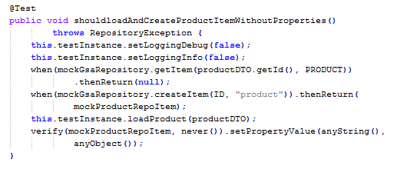
- Update Product and check if the logging is working: In this we see that the logging is set to true to check if the logging is working properly or not.
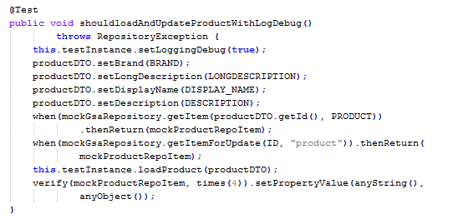
- Update product process failure: Here using the Mock object creating element and Junit when then API, we check that if there is an issue with updating a product then the exception is thrown and handled properly.
@Test(expected=<Exception.class >) annotation is used to verify if a exception of a particular type is being thrown to validate that correct exception is being checked, instead of a generic exception.
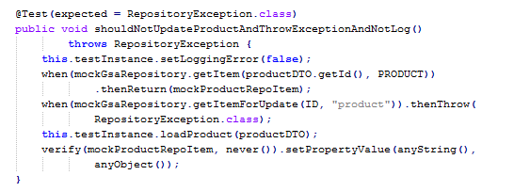

- Update Product Process failure and Logging check
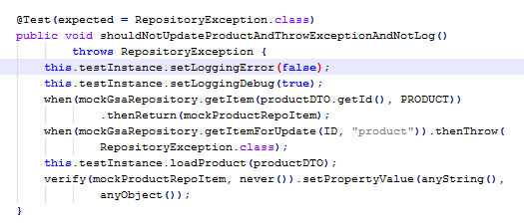

As seen above 5 test methods were written to validate the 5 different scenarios of updating a product. Similar approach needs to be used to test all the different features. Once the Test class is written then
you can proceed with the development of the actual business logic.

- Junit API'S Examples
Overview about JUnit Annotations:
Covers some of the annotations in the Mockito library – @Mock, @InjectMocks, @Before, @Test, @verify etc..
Enable Mockito Annotations
In order for these annotations to be enabled, we’ll need to annotate the JUnit test with a runner – MockitoJUnitRunner.
@RunWith(MockitoJUnitRunner.class)
public class ProductLoaderTest {
}
Alternatively we can also enable these annotations programmatically by invokingMockitoAnnotations.initMocks() as shown in the following example:
@Before
public void setUp() throws Exception {
MockitoAnnotations.initMocks(this);}

  - @Mock Annotation
@Mock – It is used to create and inject mocked instances of the java objects without having to call Mockito.Mock manually. Below examples shows how a object can be mocked in Mockito
@Mock
private GSARepository mockGsaRepository;

  - @Before Annotation
@Before - The annotated method is run before every test method of the Junit class is executed.
@Before
public void setUp() throws Exception {
MockitoAnnotations.initMocks(this);
initiateProductDTO();
this.testInstance.setLoggingDebug(true);
this.testInstance.setLoggingError(true);
this.testInstance.setLoggingInfo(true);
this.testInstance.setProductCatalog(mockGsaRepository);
}

  - @InjectMocks Annotation
@InjectMocks annotation is used to inject mock fields into the tested object automatically.

In the following example – we use @InjectMocks to inject the mock productDTO into the ProductLoader:

@InjectMocks
private final ProductLoader testInstance = new ProductLoader();
private ProductDTO productDTO;
@Test
public void shouldloadAndCreateProduct() throws RepositoryException {
productDTO.setBrand(BRAND);
productDTO.setLongDescription(LONGDESCRIPTION);
productDTO.setDisplayName(DISPLAY_NAME);
productDTO.setDescription(DESCRIPTION);
when(mockGsaRepository.getItem(productDTO.getId(), PRODUCT))
.thenReturn(null);
when(mockGsaRepository.createItem(ID, "product")).thenReturn(
mockProductRepoItem);
this.testInstance.loadProduct(productDTO);
verify(mockProductRepoItem, times(4)).setPropertyValue(anyString(),
anyObject());
verify(mockGsaRepository, times(1)).addItem(mockProductRepoItem);
}

  - @Test Annotation
@Test- The annotated method is used to run a test case and is annotated above every test method. In this test method we need to write the possible test cases for our java class. The Test annotation tells JUnit that the public void method to which it is attached can be run as a test case. To run the method, JUnit first constructs a fresh instance of the class then invokes the annotated method. Any exceptions thrown by the test will be reported by JUnit as a failure. If no exceptions are thrown, the test is assumed to have succeeded.
@Test
public void shouldloadAndUpdateProduct() throws RepositoryException {
productDTO.setBrand(BRAND);
productDTO.setLongDescription(LONGDESCRIPTION);
productDTO.setDisplayName(DISPLAY_NAME);
productDTO.setDescription(DESCRIPTION);
when(mockGsaRepository.getItem(productDTO.getId(), PRODUCT))
.thenReturn(mockProductRepoItem);
when(mockGsaRepository.getItemForUpdate(ID, "product")).thenReturn(
mockProductRepoItem);
this.testInstance.loadProduct(productDTO);
verify(mockProductRepoItem, times(4)).setPropertyValue(anyString(),
anyObject());
}
  - @Test (expected = Exception.class):
We need to test the exception to be thrown by the test. @Test annotation provides a parameter called 'expected', declares that a test method should throw an exception. If it doesn't throw an exception or if it throws a different exception than the one declared, the test fails.
@Test(expected = RepositoryException.class)
public void shouldNotloadAndCreateProductAndThrowException()
throws RepositoryException {
this.testInstance.setLoggingDebug(false);
this.testInstance.setLoggingInfo(false);
when(mockGsaRepository.getItem(productDTO.getId(), PRODUCT))
.thenReturn(null);
when(mockGsaRepository.createItem(ID, "product")).thenThrow(
RepositoryException.class);
this.testInstance.loadProduct(productDTO);
verify(mockProductRepoItem, never()).setPropertyValue(anyString(),
anyObject());
}
  - verify
Verifies certain behavior happened at least once / exact number of times / never.
E.g: verify(mockProductRepoItem, times(4)).setPropertyValue(anyString(),
anyObject());
//We can use flexible argument matchers, e.g:
verify(mockProductRepoItem, never()).setPropertyValue(anyString(),
anyObject());

- Execute/Run the Junit code:
Right click on the test class → Run As → JUnit Test

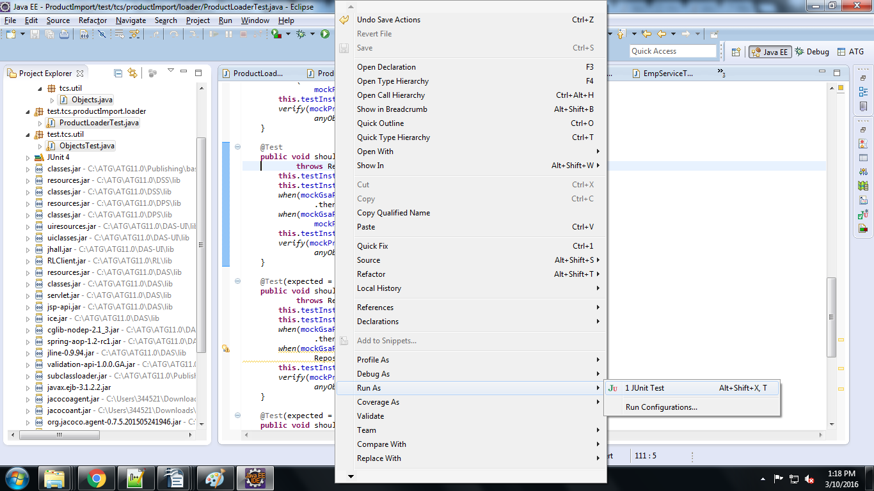

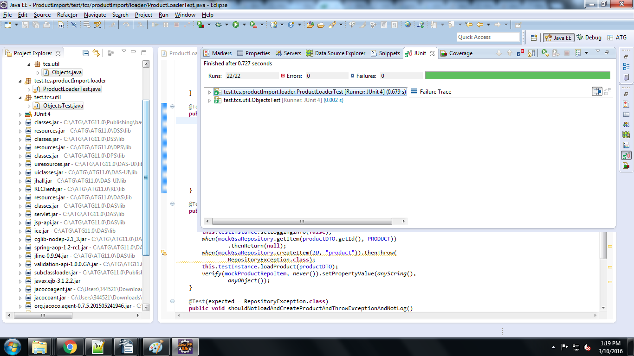

- How to see the JUnit code Coverage:
Right click on the TestClass you can see the Coverage As option to test the code coverage.
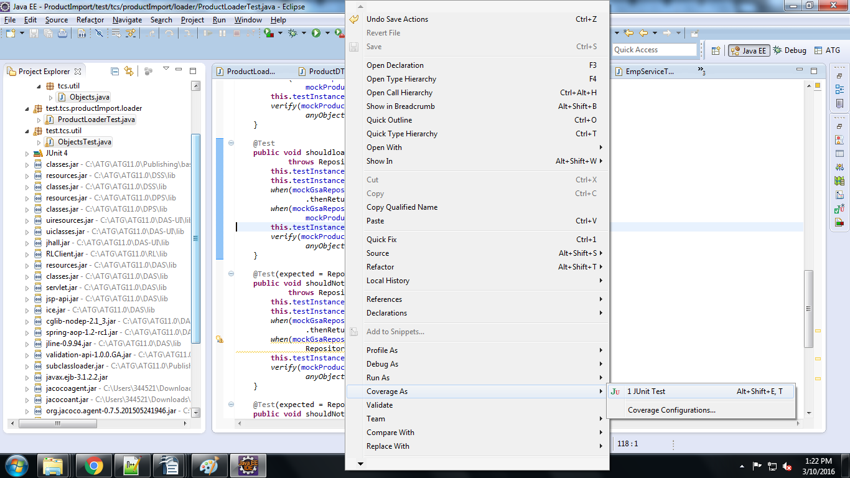
Click Coverage in Eclipse Side Bar and navigate to your particular class and you can see the code coverage in percentage.
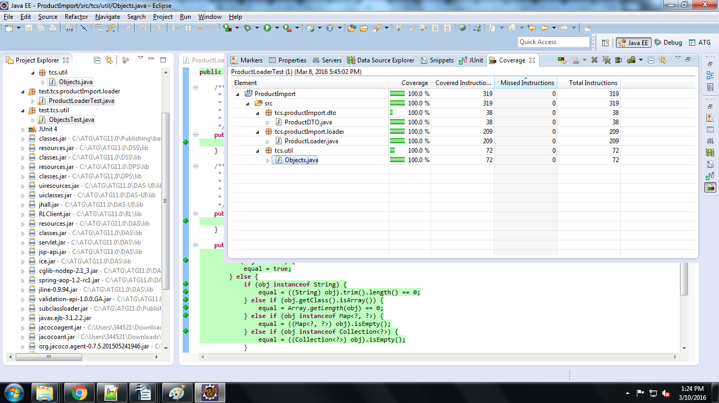

We can able to see the Code Coverage of the original java class. For example ProductLoaderTest.java is the Test class for ProductLoader.java. So we can see the code coverage of the ProductLoader.java

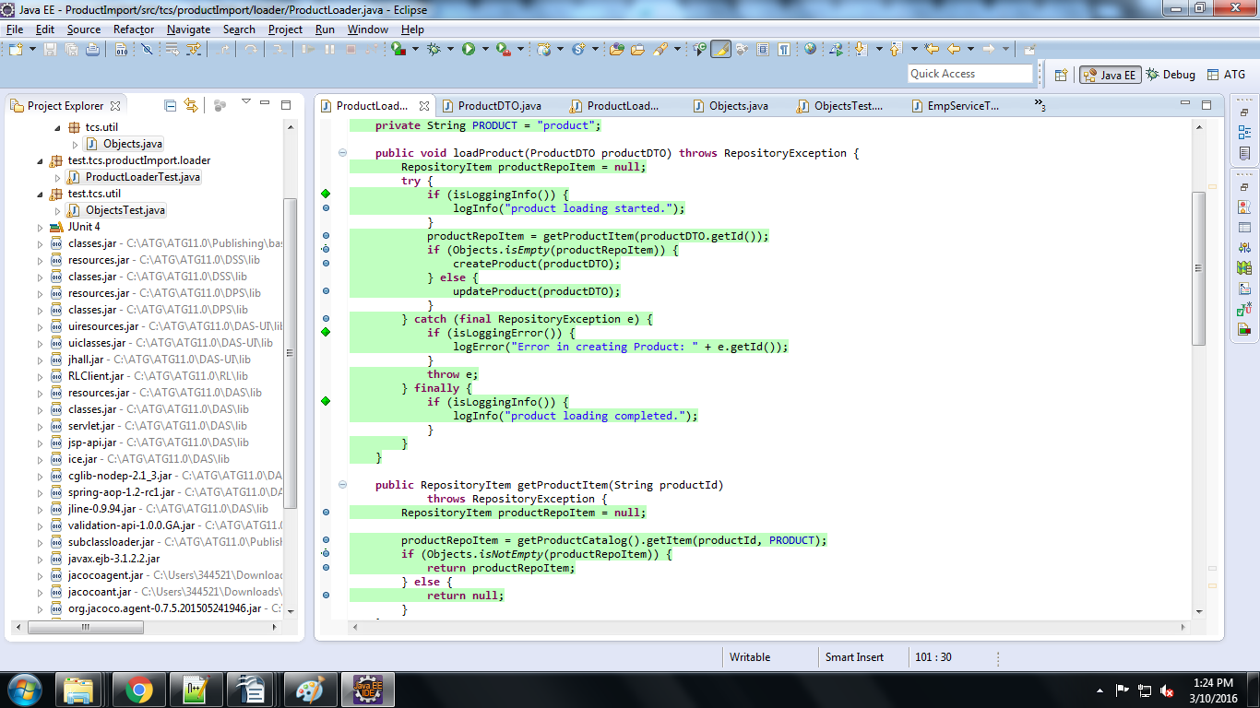
- Junit Best Practices
Below Listed are some of the Best practices that needs to be followed while writing Junits.
- Create your test case before anything else.
- Don’t just pass the test just for the sake of passing it
- Make each test independent to all the others
- Avoid writing test cases that can manipulate data.
- Test Methods names should be self descriptive and meaning full.
- A method should always asset or Verify the functionality.
- Ensure that tests are time-independent.
- Mock out all external services and state.
- Do not load data from hard-coded locations on a file systems.
- Ensure that test code is separated from production code

